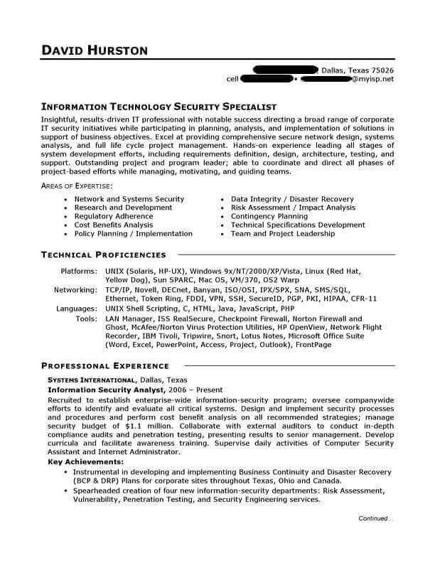
DAVID HURSTON
cell
Dallas, Texas 75026 @myisp.net
INFORMATION TECHNOLOGY SECURITY SPECIALIST
Insightful, results-driven IT professional with notable success directing a broad range of corporate IT security initiatives while participating in planning, analysis, and implementation of solutions in support of business objectives. Excel at providing comprehensive secure network design, systems analysis, and full life cycle project management. Hands-on experience leading all stages of system development efforts, including requirements definition, design, architecture, testing, and support. Outstanding project and program leader; able to coordinate and direct all phases of project-based efforts while managing, motivating, and guiding teams.
AREAS OF EXPERTISE:
⚫ Network and Systems Security Research and Development Regulatory Adherence
Cost Benefits Analysis
Policy Planning / Implementation
TECHNICAL PROFICIENCIES
Data Integrity / Disaster Recovery ⚫ Risk Assessment / Impact Analysis Contingency Planning
⚫ Technical Specifications Development Team and Project Leadership
Platforms: UNIX (Solaris, HP-UX), Windows 9x/NT/2000/XP/Vista, Linux (Red Hat, Yellow Dog), Sun SPARC, Mac OS, VM/370, 052 Warp
Networking: TCP/IP, Novell, DECnet, Banyan, ISO/OSI, IPX/SPX, SNA, SMS/SQL,
Ethernet, Token Ring, FDDI, VPN, SSH, SecureID, PGP, PKI, HIPAA, CFR-11
Languages: UNIX Shell Scripting, C, HTML, Java, JavaScript, PHP
Tools: LAN Manager, ISS RealSecure, Checkpoint Firewall, Norton Firewall and Ghost, McAfee/Norton Virus Protection Utilities, HP OpenView, Network Flight Recorder, IBM Tivoli, Tripwire, Snort, Lotus Notes, Microsoft Office Suite (Word, Excel, PowerPoint, Access, Project, Outlook), FrontPage
PROFESSIONAL EXPERIENCE
SYSTEMS INTERNATIONAL, Dallas, Texas
Information Security Analyst, 2006 - Present
Recruited to establish enterprise-wide information-security program; oversee companywide efforts to identify and evaluate all critical systems. Design and implement security processes and procedures and perform cost benefit analysis on all recommended strategies; manage security budget of $1.1 million. Collaborate with external auditors to conduct in-depth compliance audits and penetration testing, presenting results to senior management. Develop curricula and facilitate awareness training. Supervise daily activities of Computer Security Assistant and Internet Administrator.
Key Achievements:
• Instrumental in developing and implementing Business Continuity and Disaster Recovery (BCP & DRP) Plans for corporate sites throughout Texas, Ohio and Canada.
• Spearheaded creation of four new information-security departments: Risk Assessment, Vulnerability, Penetration Testing, and Security Engineering services.
Continued..

